
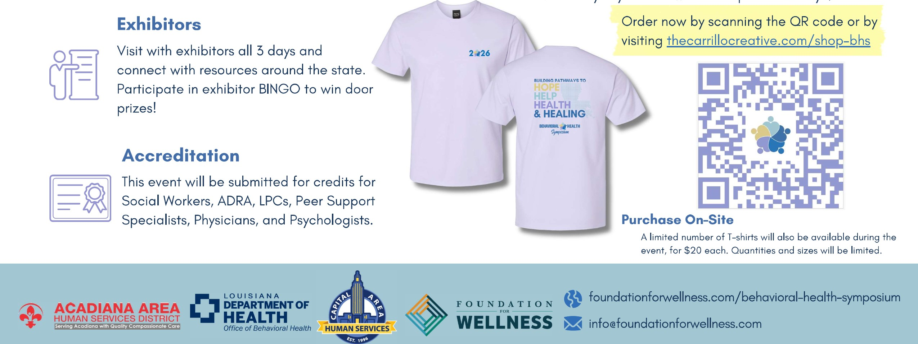
Purchase your T-shirt before the symposium to take access to all 5 days of education, advantage of pre-event pricing and guarantee breakfast, lunch, and certificates.
Entry
sold
as
one-time
$50
registration
fee
for
full
5-day
conference
event
-
no
Order
Early
and
Save!
daily
rates
available.
Registration
includes

